|  |  |
| --- | --- |
| Course Name | ITD 2313 – Script Programming |
| Instructor | Mark L. Pranger |
| Student Name | Thomas Webb |
| Due date | 6/17/2025 |
| Grade | Put grade earned here |
| Grading Comments | Put instructor comments here |

Page 116-117

Exercise 1

Exercise 2

Exercise 3

Exercise 4

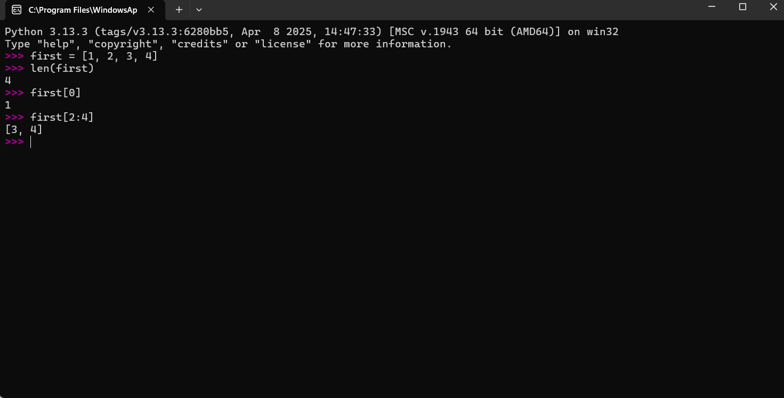

Exercise 5

Exercise 6

Exercise 7

Exercise 8

Page 118

Example code 1

Example code 2

example code 3

Page 119-120

Example code 1

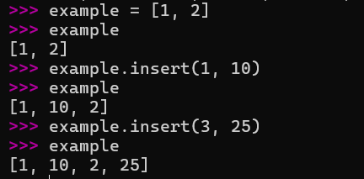

example code 2

Example code 3

Page 121

example code 1

Page 122

Example code 1

Page 123

Example code 1

Page 124

Example code 1

Example code 2

Example code 3

Page 126

Page 127

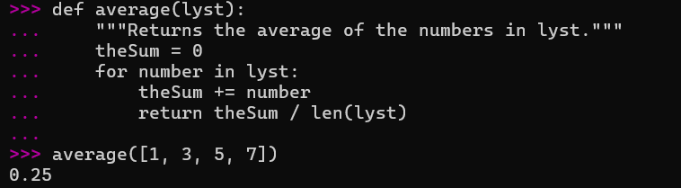

Page 128

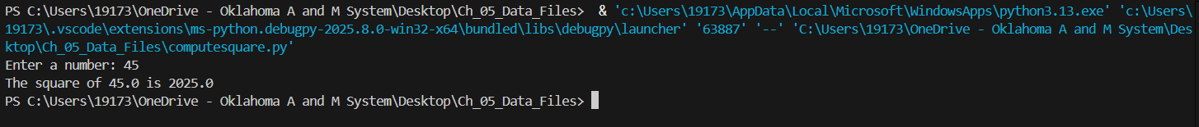

Page 132

Example code 1

Page 133

Example code 1

Example code 2

Pages 134-135

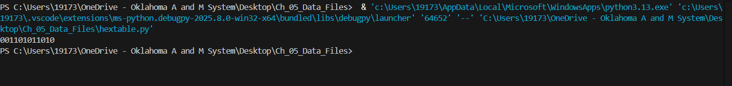

Page 135

